OSPF Write-Up

By Diego Santos

**Background**

* OSPF was developed in 1988
* OSPF is called (Open Shortest Path First)
* It gives a very good benefit of routing areas

**Purpose**

The purpose of this lab was how to activate OSPF on a set of routers using IPv4 addresses

**Lab Summary**

* After setting up the topology I configured both the PCs and routers with IPV4 addresses then used the Router OSPF command on all routers then setting the routing area with the Network (Network)(Subnet Address) Area 0 Command to configure and that’s was all set up I did a show Ip route and tested the pings between the PCs to finish the lab.

**Lab Commands**

* Network (Network)(Subnet Address) Area 0 (Creates a router area and adds the network to said area)
* Router ospf (Activates ospf on a router)

**Network Diagram with IP’s**

* 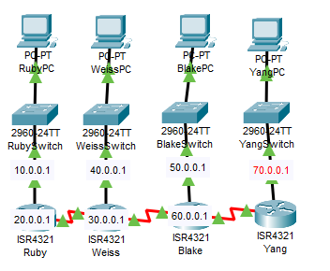

**Configurations**

* 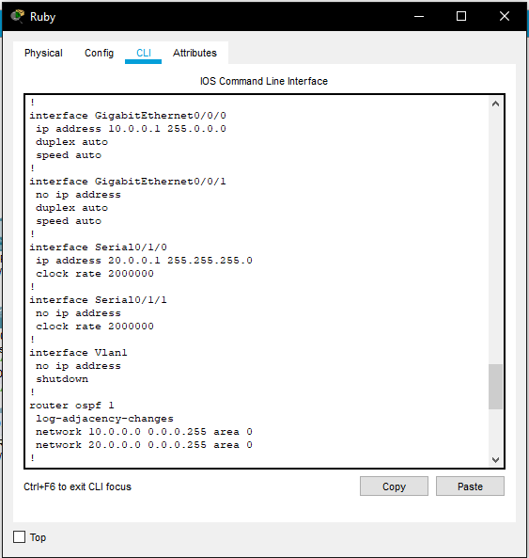
* 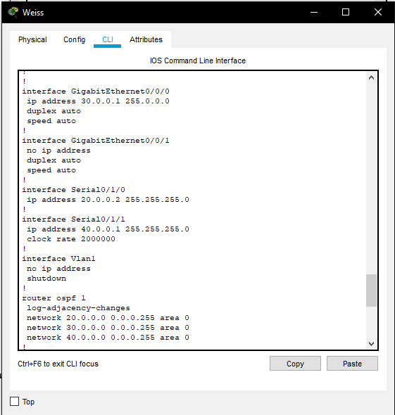
* 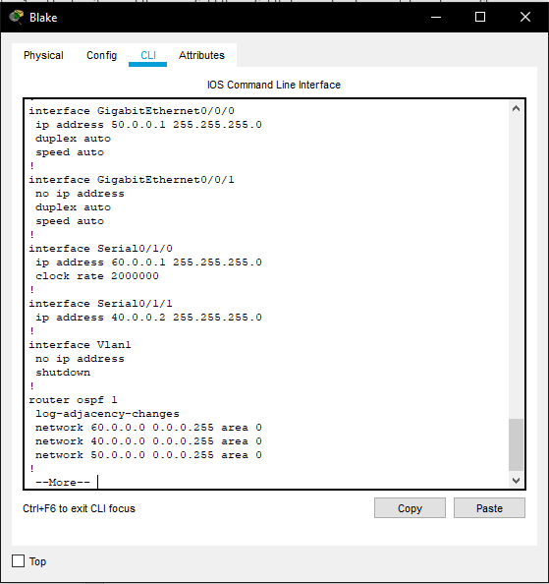
* 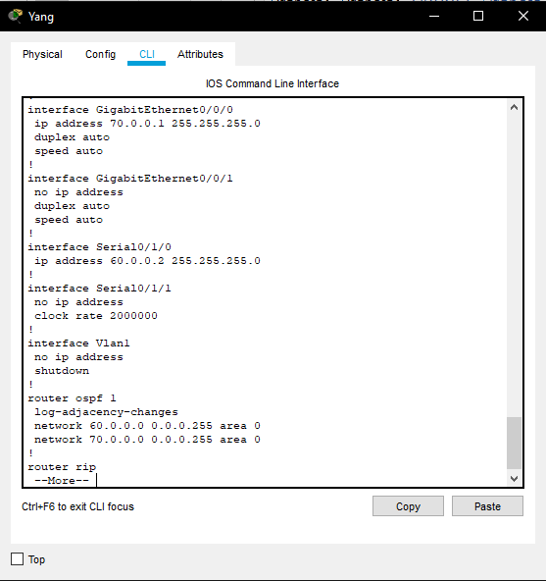

**Problems**

* I forgot the Network routing area command

**Conclusion**

* After setting up OSPF with ipv4 addresses on a set of 4 routers, I realized that I had forgotten the network ospf command and I learned to not forget basic commands